Live Stock production

1. Total milk production in the country during 2021-22 is **221.06 million tonnes**.
2. In the current year 2021-22, the milk production has registered an annual growth rate of **5.29%**.
3. Top five major milk producing States are Rajasthan (15.05%), Uttar Pradesh (14.93%), Madhya Pradesh (8.06%), Gujarat (7.56%) and Andhra Pradesh (6.97%).
4. In 2021-22, the total egg production in the country is **129.60 billion nos** which has increased by **6.19%** as compared to previous year.
5. Total five major egg producing States are Andhra Pradesh (20.41%), Tamil Nadu (16.08%), Telangana (12.86%), West Bengal (8.84%) and Karnataka (6.38%).
6. The total meat production in the country is **9.29 million tonnes** for the year 2021-22 with an annual growth rate of **5.62%.**
7. The total five major meat producing States are Maharashtra (12.25%), Uttar Pradesh (12.14%), West Bengal (11.63%), Andhra Pradesh (11.04%), and Telangana (10.82%).
8. The total wool production in the country during 2021-22 is **33.13 thousand tonnes** which has decline by 10.30% as compared to previous year.
9. The top five major wool producing States are Rajasthan (45.91%), Jammu and Kashmir (23.19%), Gujarat (6.12%), Maharashtra (4.78%) and Himachal Pradesh (4.33%).
10. The per-capita availability of milk is **444 gram/day** during 2021-22 increased by 17 gram/day over previous year.
11. In 2021-22, the per-capita availability of egg is **95 nos/annuam** increased by 5 nos/annuam over previous year.
12. The per-capita availability of meat is **6.82 kg/annuam** during 2021-22 increased by 0.30 kg/annuam over previous year.
13. During 2014-15 and 2020-21, the value addition of sector grew at a compound annual growth rate of 7.93%.
14. In 2020-21, the share of Livestock at constant prices in Agriculture Sector and total GVA was 30.13% and 4.9% respectively.

Links to reports

[MLPGrowthRate2022-23.pdf (dahd.nic.in)](https://dahd.nic.in/sites/default/filess/MLPGrowthRate2022-23.pdf)

[BookBAHS2020Final.pdf (dahd.nic.in)](https://dahd.nic.in/sites/default/filess/BookBAHS2020Final.pdf)

1961-1971

1. **Milk Production**:
   * India’s milk production during the 1960s and 1970s was primarily driven by traditional dairy farming.
   * **Uttar Pradesh**, **Rajasthan**, and **Gujarat** were prominent contributors to milk production during this period.
   * [The **Green Revolution** in agriculture also had a positive impact on dairy farming, leading to increased milk yields2](https://mospi.gov.in/sites/default/files/reports_and_publication/cso_national_accounts/Estimates_Output_Agriculture_and_Livestock/intro-eng.pdf).
2. **Milk Production**:
   * India’s milk production during the 1960s and 1970s was primarily driven by traditional dairy farming.
   * **Uttar Pradesh**, **Rajasthan**, and **Gujarat** were prominent contributors to milk production during this period.
   * [The **Green Revolution** in agriculture also had a positive impact on dairy farming, leading to increased milk yields2](https://mospi.gov.in/sites/default/files/reports_and_publication/cso_national_accounts/Estimates_Output_Agriculture_and_Livestock/intro-eng.pdf).
3. **Meat Production**:
   * Meat production during this time was influenced by factors such as population growth, dietary preferences, and economic development.
   * **Maharashtra**, **Uttar Pradesh**, and **West Bengal** were among the major meat-producing states.
   * [The demand for meat increased steadily, reflecting changing consumption patterns3](https://www.indiastat.com/data/agriculture/meat-production/data-year/all-years).
4. **India as Largest Milk Producer**: In 1998-99, India became the largest producer of milk globally, with an annual production of 74 million tonnes.
5. **Operation Flood**: The initiation of Operation Flood in the early seventies acted as a catalyst for milk production in India. This initiative provided a significant stimulus, leading to sustained growth in milk production.
6. **Factors Driving Milk Production**: The growth in milk production can be attributed to both improvements in productivity and a shift in priorities towards buffalo and crossbred cattle.
7. **Low Productivity Compared to Potential**: Despite significant growth, the productivity of milk in India remains low compared to its potential and the world average.
8. **Tremendous Growth in Meat Output**: Since the eighties, there has been tremendous growth in meat output in India. However, this growth is primarily due to an increase in the number of animals slaughtered rather than improvements in productivity.
9. **Low Productivity in Meat Production**: The productivity of most meat-producing species in India is low and shows no signs of significant growth.
10. **Egg Production**: Egg production in India is largely driven by population growth. Similar to meat production, productivity in egg production is low.
11. **Productivity Lag in Other Products**: Except for milk, other livestock products such as meat and eggs are lagging behind in terms of productivity.

[pb7.pdf (icar.gov.in)](https://krishi.icar.gov.in/jspui/bitstream/123456789/700/1/pb7.pdf)

live stock reports

<https://www.researchgate.net/publication/339228652_Livestock_Sector_in_India_A_Critical_Analysis>

During the late 1990s, several factors contributed to the growth of **livestock production** in India. Let’s delve into these techniques and their associated statistics:

1. **Improved Breeding and Genetics**:
   * **Crossbreeding programs** were implemented to enhance the productivity of indigenous cattle breeds. This involved mating native breeds with high-yielding exotic breeds like Holstein-Friesian and Jersey.
   * **Artificial insemination** (AI) was widely adopted to improve the genetic potential of dairy animals. AI allowed farmers to use superior bull semen for breeding, leading to better milk production.
2. **Nutrition Management**:
   * **Balanced feed formulation** became crucial. Farmers started using a mix of green fodder, dry roughage, and concentrated feed to meet the nutritional requirements of livestock.
   * **Supplementary feeding** with protein-rich concentrates improved animal health and productivity.
3. **Healthcare and Disease Control**:
   * **Vaccination programs** were intensified to prevent common livestock diseases. Vaccines against foot-and-mouth disease, brucellosis, and other ailments were administered.
   * **Regular deworming** and parasite control measures were implemented to maintain herd health.
4. **Infrastructure Development**:
   * **Dairy cooperatives** like Amul played a pivotal role. They provided necessary infrastructure for milk collection, processing, and marketing.
   * **Cold storage facilities** were established to preserve milk and meat products.
5. **Government Policies and Support**:
   * The Indian government introduced **livestock development schemes** that incentivized farmers to invest in animal husbandry.
   * **Subsidies** for inputs like feed, fodder, and veterinary services encouraged farmers to adopt modern practices.

[Performance of Livestock Sector in India (With Reference to Bovine Population) – Current Agriculture Research Journal (agriculturejournal.org)](https://www.agriculturejournal.org/volume4number1/performance-of-livestock-sector-in-india/)

Article summary

It is observed that the buffalo population is increasing. But the growth in cattle and total live stock was negative in 2012. The percentage of cross breed cattle is increasing while that of indigenous is declining slowly. In 2012 the percentage of male cattle in total indigenous cattle was high (41.0%) and the same in crossbreed cattle was low at 15.0%. The production of milk and per capita availability of milk increased significantly over a period of time. At the same time the share of live stock sector in Agriculture GDP showed increasing trend. The statistics reveal that India is the largest milk producer in the world. But the milk yield per head is low. Hence there is need to raise the milk yield in order to enhance the per capita availability of milk and to meet the increasing demand. Measures must be taken to protect the cattle and to increase their number.

<https://www.researchgate.net/publication/268048535_Livestock_sector_development_and_implications_for_rural_poverty_alleviation_in_India>

* + - Talks about the same thing**(increase in cross breed and decline of ingenious breeds)** with maybe additional info and stats that might be useful

A different article

<file:///C:/Users/haree/Downloads/Trends_and_Developments_in_Indias_Livestock_Indus.pdf>

Key points from article.

1. **Cattle Population Trends**: India's total cattle population growth rates remained relatively stable over time, with 0.11% per annum from 1960 to 1979 and 0.27% per annum from 1980 to 1997. However, there was a substantial decline in the population of work animals due to mechanization, particularly the increased use of tractors associated with the Green Revolution.
2. **Buffalo Population and Milk Production**: The buffalo population in India increased significantly, with a growth rate of 0.57% per annum from 1960 to 1979 and 0.82% per annum from 1980 to 1997. This growth contributed to the shift in bovine sex ratios in favor of females, particularly she-buffaloes, which are preferred for milk production due to the high demand for buffalo milk in India.
3. **Shift in Livestock Preferences**: There has been a shift towards monogastric animals, particularly chickens and pigs, which has reduced the dominance of ruminant meat in India's red meat supply. This shift is expected to continue, leading to more intensified livestock production practices.
4. **Sheep and Goat Population Trends**: Sheep and goat populations in India have increased, with growth rates of around 0.5% per annum for sheep and 0.6% to 0.8% per annum for goats after 1980. These species play a crucial role in providing income and employment to poor households in drought-prone areas.
5. **Pig and Poultry Industry Growth**: India's pig population, although low by world standards, has shown growth rates above 1% per annum. The poultry industry has experienced significant growth, with chicken numbers increasing at a rate of around 4.3% per annum after 1980 due to improvements in breeding technology.
6. **Milk Production and Operation Flood**: India's milk production has increased threefold since the 1960s, with buffalo and cow milk contributing equally. Operation Flood, implemented under the guidance of the National Dairy Development Board, has been instrumental in linking rural milk producers with urban markets through cooperative dairying.
7. **Regional Concentration of Milk Production**: Milk production is concentrated in Western states like Gujarat and Maharashtra, with distribution extending to Eastern states like Bihar and West Bengal. This regional concentration is influenced by factors such as breed adaptability, availability of feed, and the establishment of dairy development institutions.

Artificial Insemination in animals

[View of Artificial insemination for milk production in India: A statistical insight (icar.org.in)](https://epubs.icar.org.in/index.php/IJAnS/article/view/109314/43121)

1. **Advantages of Artificial Insemination**:
   * **Rapid Improvement**: AI leads to rapid improvement in herd, milk, and beef production.
   * **Best Bull Utilization**: It allows extensive utilization of genetically superior bulls, providing farmers with a wider choice.
   * [**Cost-Effective**: A single ejaculate from a bull can serve many cows (400+), eliminating the need to keep one bull for every 25–30 cows1](https://www.bivatec.com/blog/artificial-insemination-in-livestock).
   * **Genetic Improvement**: AI facilitates the introduction of superior sires, enhancing the overall genetic quality of the herd.
   * **Disease Control**: By using AI, the risk of sexually transmitted diseases is minimized.
   * [**Long-Term Storage**: Semen from exceptional males can be stored for over 40 years under deep freezing conditions2](http://naas.org.in/Policy%20Papers/policy%2096.pdf).
2. India’s livestock sector has benefited from AI, leading to improved nutritional security and reduced rural poverty.

Milk production increased significantly, even as the cattle and buffalo populations grew at a slower rate.

[However, the overall AI coverage in bovines (cattle and buffaloes) remains at only 30%, with a conception rate of 35%2](http://naas.org.in/Policy%20Papers/policy%2096.pdf).

Covid-19 effect(Related to Artificial Insemination)

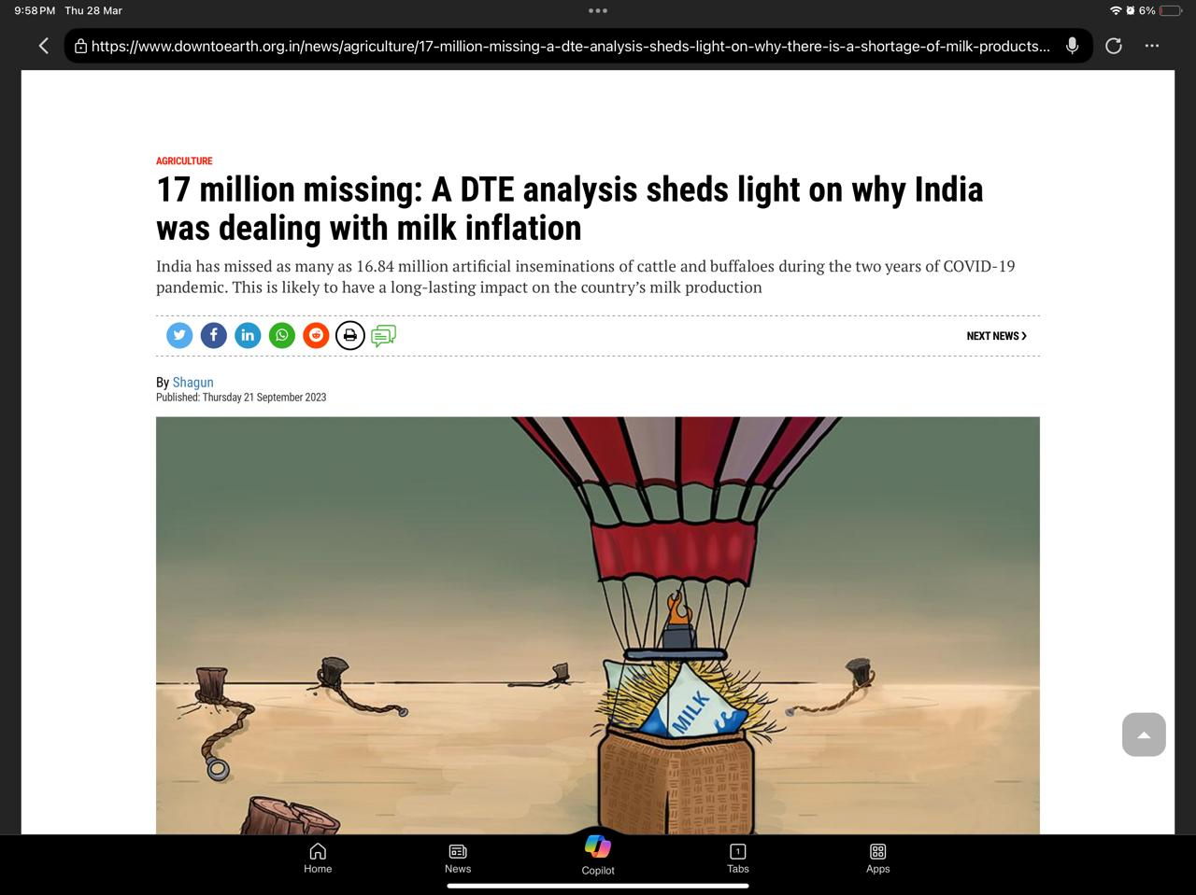

<https://www.downtoearth.org.in/news/agriculture/17-million-missing-a-dte-analysis-sheds-light-on-why-india-was-dealing-with-milk-inflation-91390>

